Preparing a two-column paper
A. N. Author^{a,*} and A. N. Author^{b}
ªDepartment, University, City, State/Province, Country
^{b}Department, University, City, State/Province, Country
*Corresponding author: provide full correspondence details here including e-mail for the corresponding author

ABSTRACT: This template helps you to create properly formatted Word manuscript for the Journal of Coastal and Offshore Science and Engineering. A concise abstract is required (maximum length 300 words). The abstract should state briefly the purpose of the research, the principal results and major conclusions.
KEYWORDS: Keyword1, Keyword2, Keyword3. Immediately after the abstract, provide a maximum of 6 keywords, avoiding general and plural terms and multiple concepts (avoid, for example, “and”, “of”). Also, avoid using words that are already in the title. Be sparing with abbreviations: only abbreviations firmly established in the field may be eligible. These keywords will be used for indexing purposes.

GENERAL INSTRUCTIONS

Typefont and typesize
Use Times New Roman 12 point size. Use roman type except for the headings, parameters in mathematics. Never use bold, except to denote vectors in mathematics. Never underline any text. Use the small font for tables, figure captions and the references.
Never use letterspacing and never use more than one space after each other.

LAYOUT OF TEXT

Structure
Follow this order when typing manuscripts: Title, Authors, Affiliations, Abstract, Keywords, Main text (including figures and tables), Acknowledgements, References, Appendix. Please make sure that you use as much as possible normal fonts in your documents. To avoid unnecessary errors you are strongly advised to use the ‘spellchecker’ function of MS Word.
Avoid hyphenation at the end of a line. Symbols denoting vectors and matrices should be indicated in bold type. Scalar variable names should normally be expressed using italics. Weights and measures should be expressed in SI units. All non-standard abbreviations or symbols must be defined when first mentioned, or a glossary provided.
Divide your article into clearly defined and numbered sections. Subsections should be numbered 1.1 (then 1.1.1, 1.1.2, …), 1.2, etc. (the abstract is not included in section numbering). Use this numbering also for internal cross-referencing: do not just refer to “the text.” Any subsection may be given a brief heading. Each heading should appear on its own separate line.

Figures and Tables
Figures: figures should be embedded in the text. Further, high-resolution graphics files (minimum resolution of 300 dpi) must be provided separately during the submission of the Manuscript. Figures, photographs, etc. can be in black/white or full color. In the text, refer to each Figure with Fig. 1 or (Fig. 1). Never place any text next to a figure. Leave this space blank.
Tables: please insert tables as editable text and not as images. Locate tables close to the first reference to them in the text and headings should be placed above tables. Vertical lines should not be included in tables. In the text, refer to each Table with Tab. 1 or (Tab. 1).
Both Figures and Tables should have a caption and should be numbered consecutively in accordance with their appearance in the text. Place the caption underneath the figure and above the table.
Type as follows:
Table 1. Type your title here. Obtain permission and include the acknowledgement required by the copyright holder if a table is being reproduced from another source.
Figure 1. Type your caption here. Obtain permission and include the acknowledgement required by the copyright holder if a figure is being reproduced from another source.
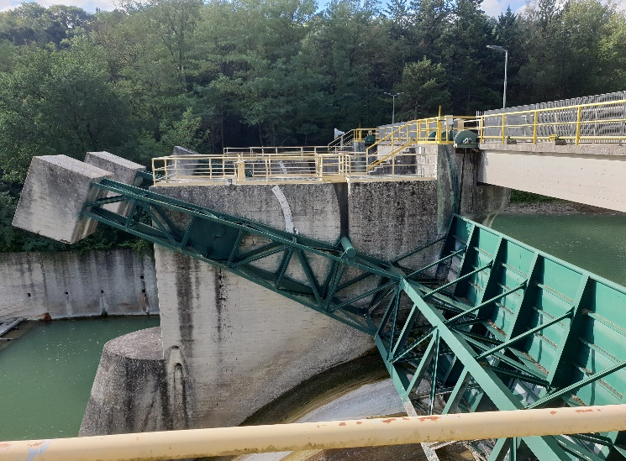
Figure 1. Caption of a typical figure. Photographs will be scanned by the printer. Always supply original photographs.

Equations
Please submit math equations as editable text and not as images. Use the equation editor of the selected word processing program. Equations are not indented. Number equations consecutively and place the number with the tab key at the end of the line, between parentheses. In the text refer to equations by these numbers (e.g., Eq. 1). Do not use the equation editor between text on same line.
From the above we note that sin θ = (x + y)z or:
(1)

Listing and numbering
When listing facts use either the style tag List signs or the style tag List numbers.

References
Please ensure that every reference cited in the text is also present in the reference list (and vice versa). References in the text: citations may be made directly (or parenthetically). Groups of references should be listed first alphabetically, then chronologically (if several works by the same author are cited).
Place the authors’ last names (without initials, unless there is ambiguity) and the date of publication in parentheses as follows:
  - single Author: the Author’s family name (without initials, unless there is ambiguity) and the year of publication;
  - two Authors: both Authors’ family names and the year of publication;
  - three or more Authors: first Authors’ family name followed by “et al.” and the year of publication.
At the end of the paper all references underneath the heading REFERENCES. References must be listed in alphabetic order and then further sorted chronologically if necessary. More than one reference from the same Author(s) in the same year must be identified by the letters “a”, “b”, “c”, etc., placed after the year of publication. Do not begin them on a new page unless this is absolutely necessary.

Conclusions
Conclusions should state concisely the most important propositions of the paper as well as the author’s views of the practical implications of the results.
ACKNOWLEDGEMENTS
Collate acknowledgements, including information on grants received, in a separate section at the end of the article and do not, therefore, include them on the title page, as a footnote to the title or otherwise.
Authors must identify who provided financial support for the conduct of the research and/or preparation of the article and to briefly describe the role of the sponsor(s), if any, in study design; in the collection, analysis and interpretation of data; in the writing of the report; and in the decision to submit the article for publication.
In the Acknowledgements Section please include the following sentence:
“This work was supported by xxx [grant numbers xxxx, yyyy]; or, if no funding has been provided for the research, please include the following sentence:
“This research did not receive any specific grant from funding agencies in the public, commercial, or not-for-profit sectors”.
REFERENCES
Last name, First name Initials (year). Book title. XXXX: Publisher X.
Last name, First name Initials (year). Title of article. Title of Journal (series number if necessary) volume number (issue number if necessary): page numbers.

